LAB EVAL-2

ROLLNO:CB.EN.U4CSE20226

NAME:K.SUJITH REDDY

PART A:

Number of Purple flowering plants-705+26=731

Number of Simulations should be-2000-226=1774

1)

NULL HYPOTHESIS: plants need to bear purple or white flowers at random that are in the ratio 3:1

ALTERNATIVE HYPOTHESIS: plants ratio for purple to white is not 3:1

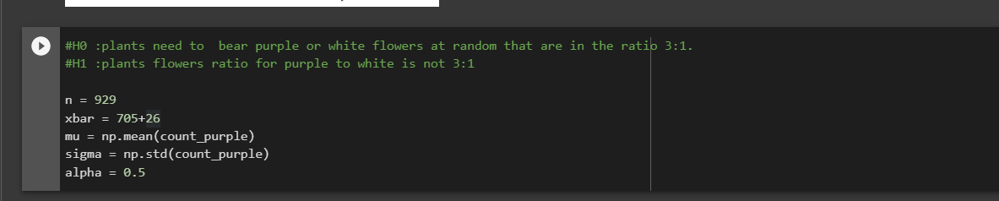

2)

Used Z- test to see the correctness as number of samples are greater than 30 and standard deviation is known.

3)

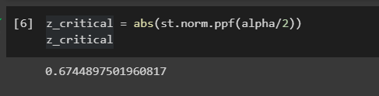

4)

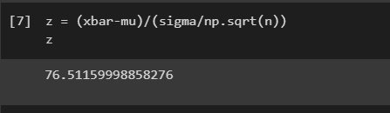

5)

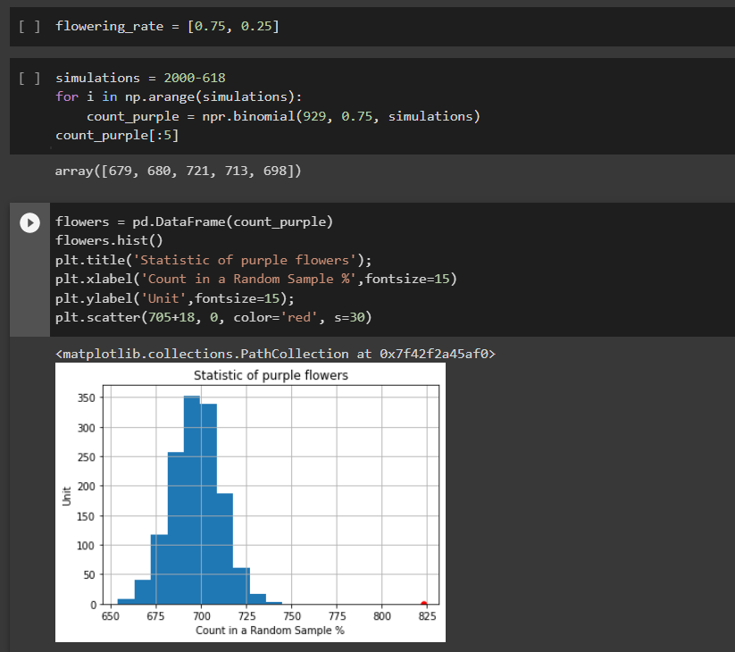

6)

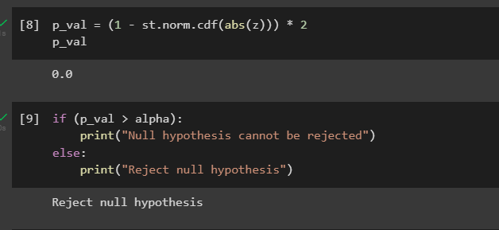

PART B:

